**SUPPLEMENTARY MATERIALS**



**Supplementary Figure S3.** N-mixture model performance (relative RMSE curves) and optimal number of visits for two different total budgets (2k = 2000 flights, 4k = 4000 flights) in six scenarios of local abundance {0.2; 1} and availability probabilities {0.2; 0.4; 0.6}. Lower panels show the optimal number of visits (i.e. lowest rel.RMSE) and the bars correspond to the range of visits for which the performance can be considered equivalent (i.e. rel.RMSE < 0.5%).

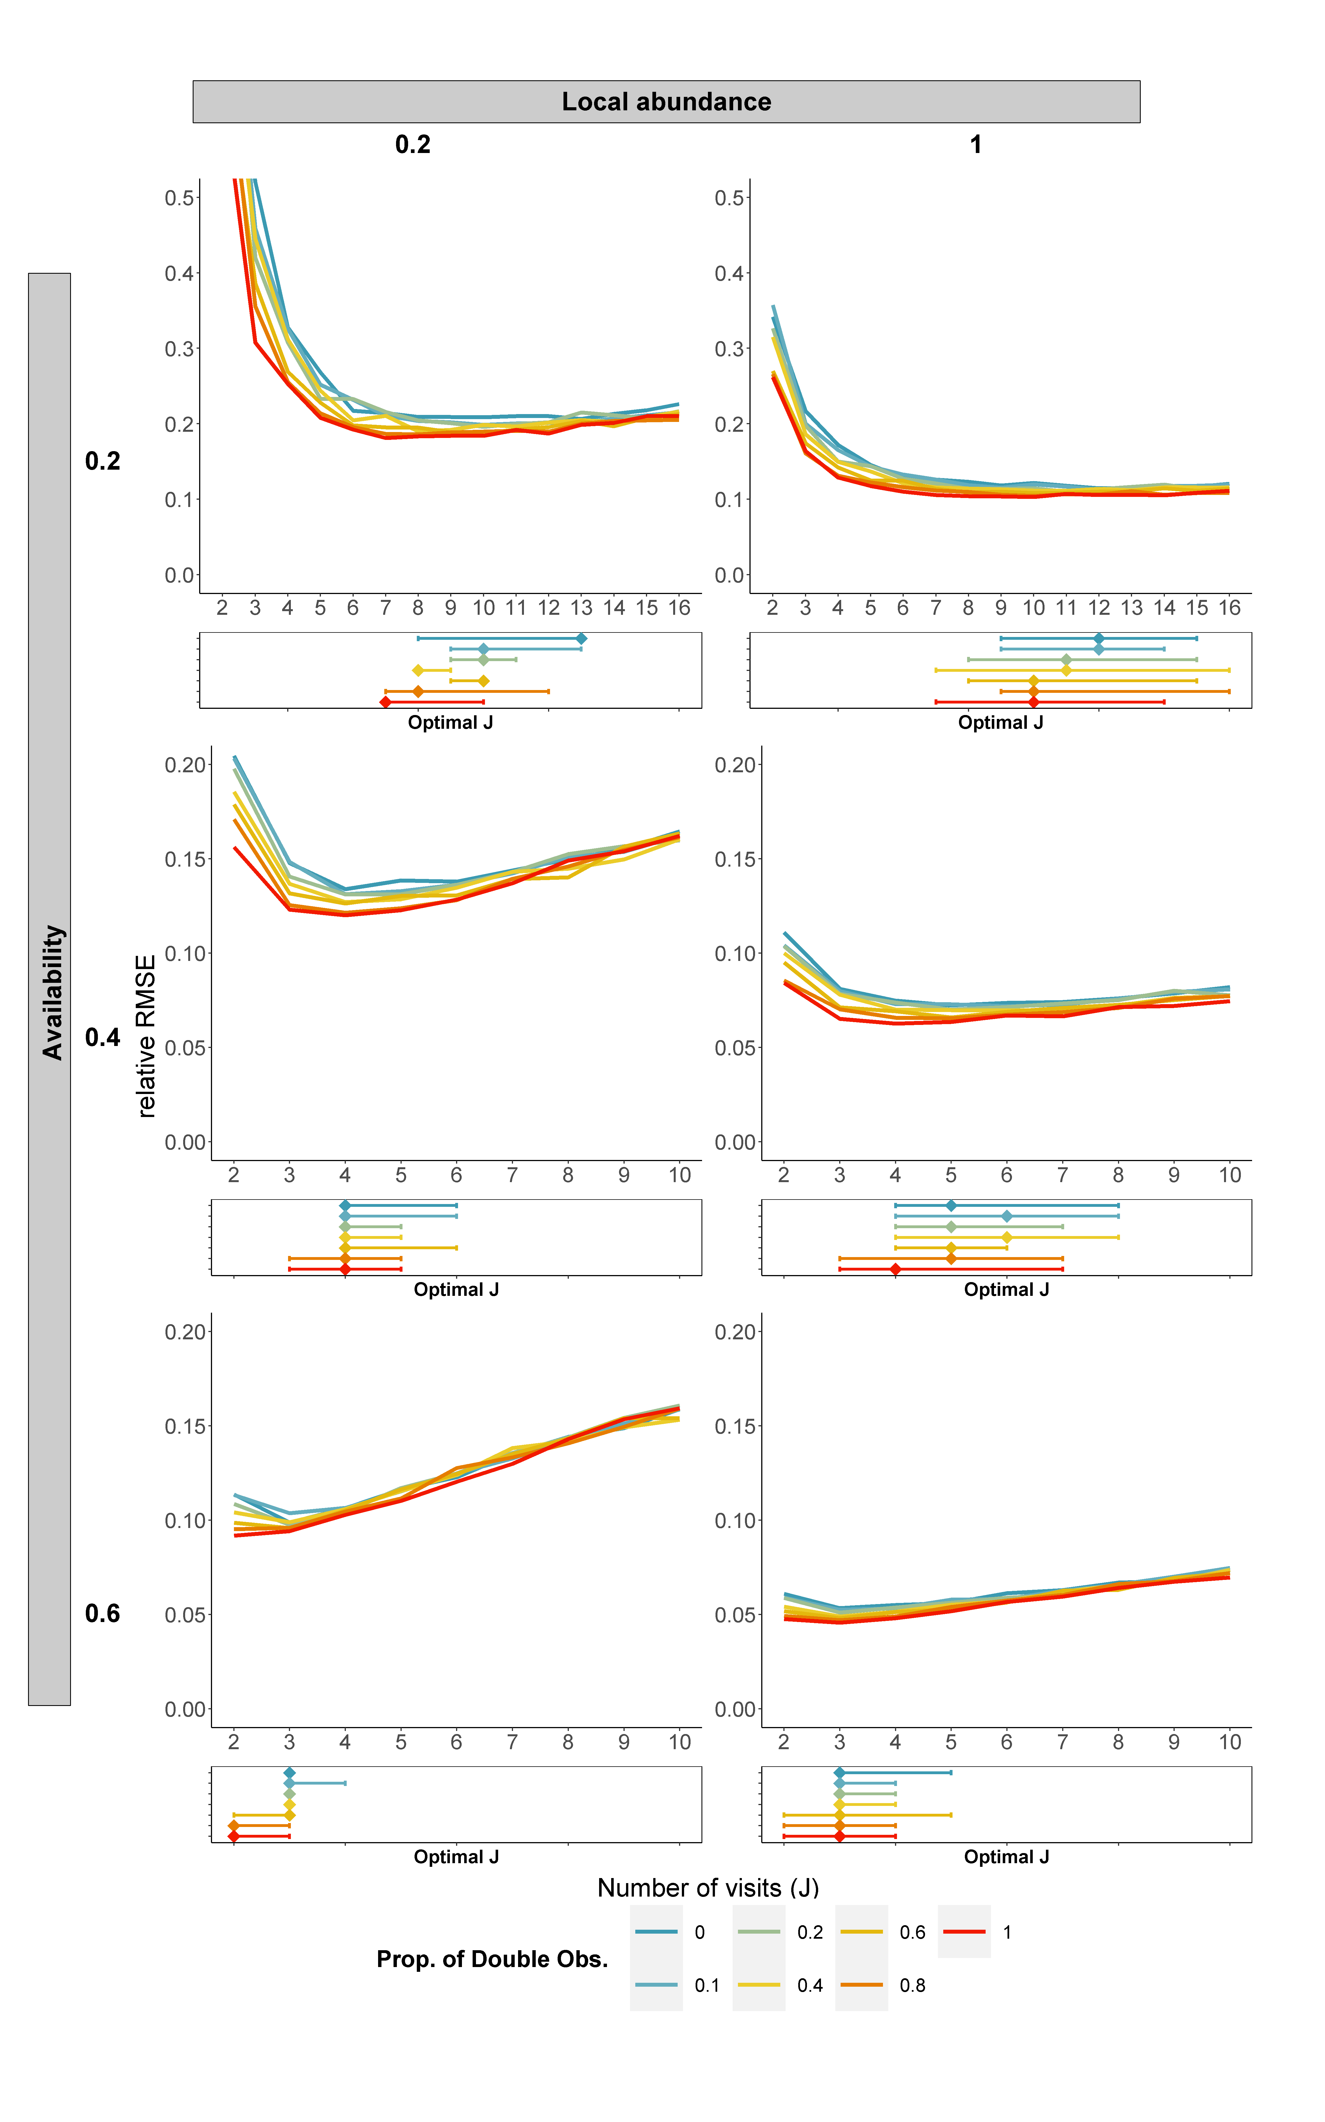

**Supplementary Figure S4.** N-mixture model performance (relative RMSE curves) and optimal number of visits using different proportions of double-observer protocol for six scenarios, from the combination of local abundances {0.2; 1} and availability probabilities {0.2; 0.4; 0.6}. Lower panels show the optimal number of visits (i.e. lowest rel.RMSE) and the bars correspond to the range of visits for which the performance can be considered equivalent (i.e. rel.RMSE < 0.5%).

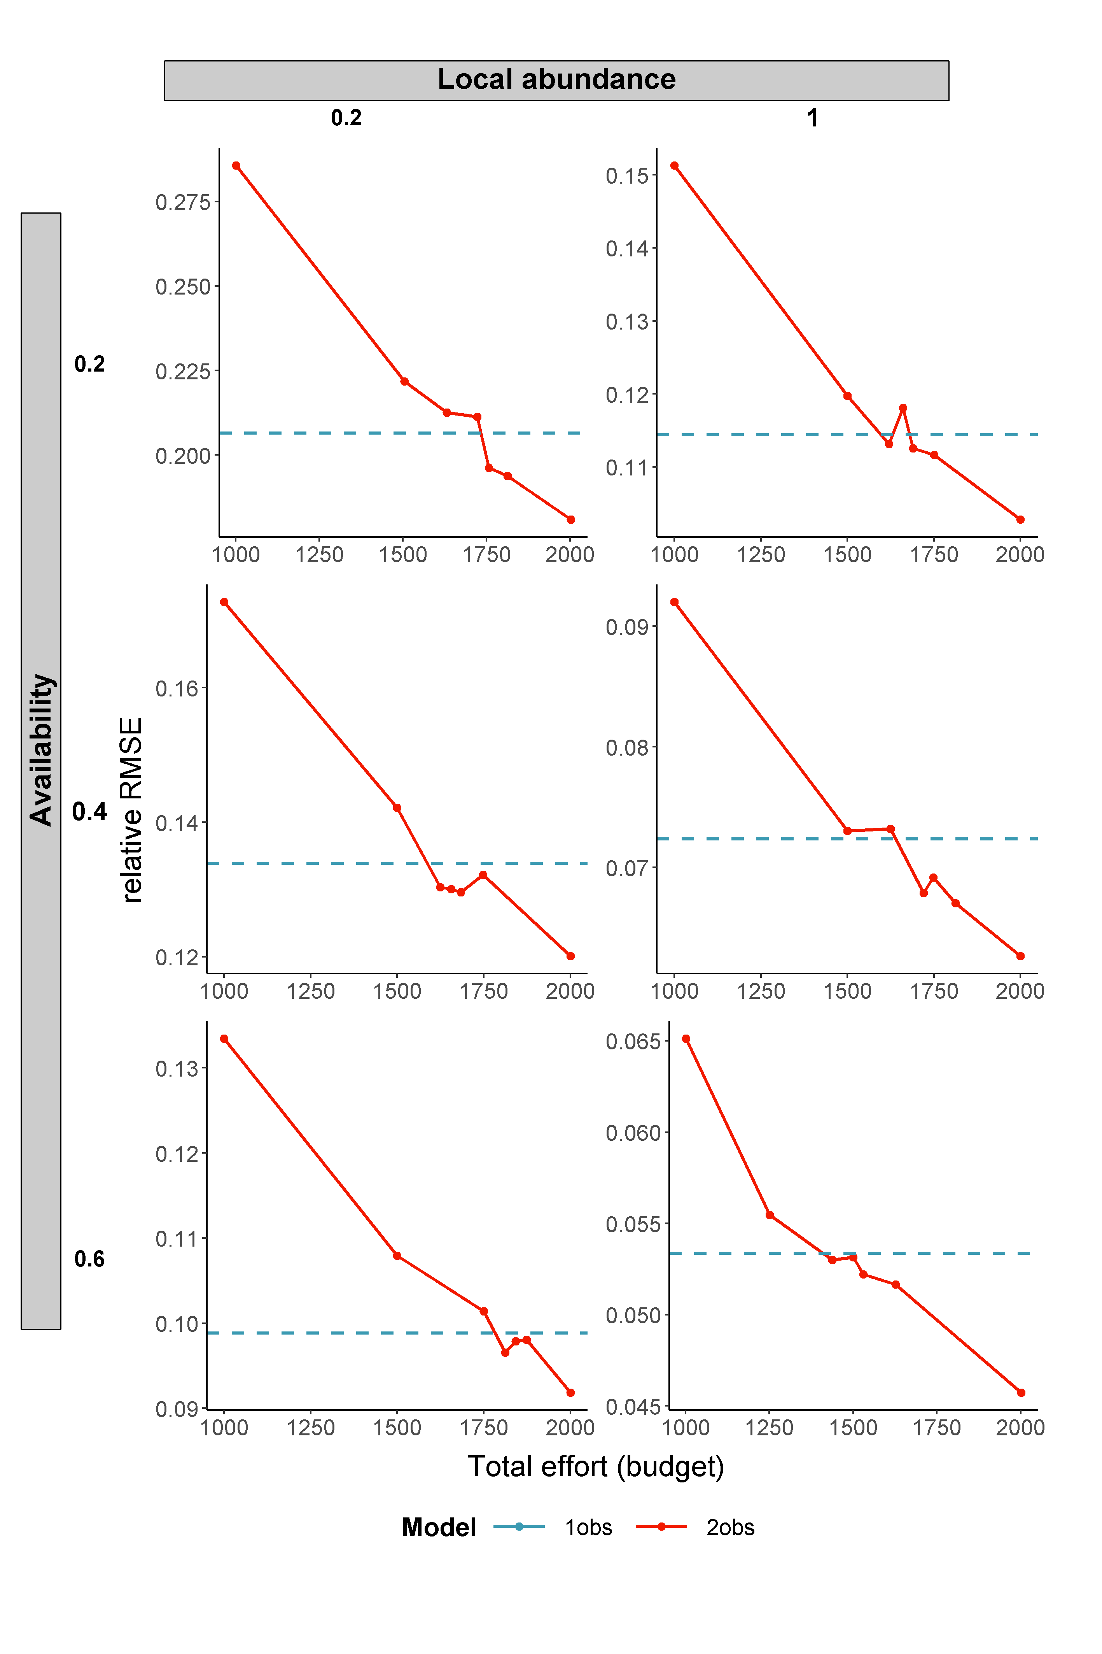

**Supplementary Figure S5.** Performance (relative RMSE) of the double observer (multinomial) N-mixture model for different total efforts (sites x visits) in comparison with the performance of a baseline single observer (binomial) N-mixture model with total effort = 2000.